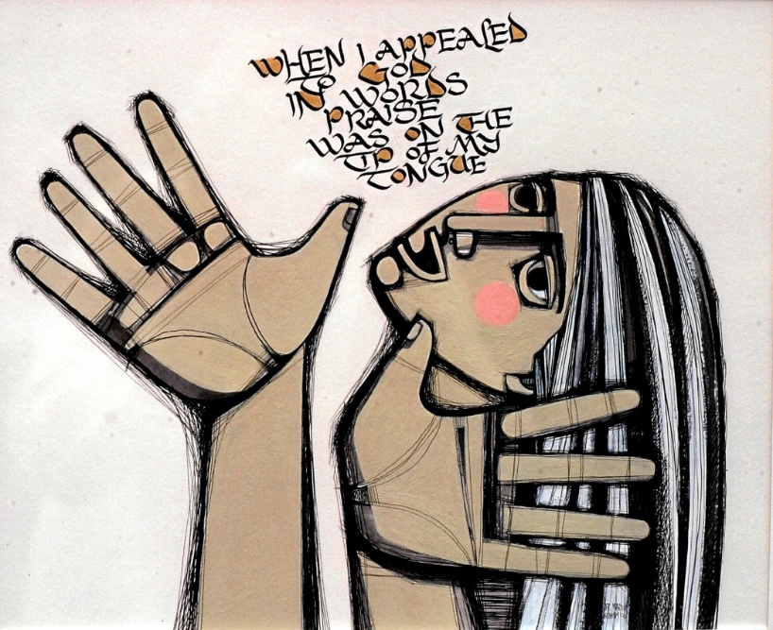
Ps. 66:17 by Marion Honors, CSJ
Celebrating the Bliss of Being - The “Beatitudes of Being” are a path to the fullness of being human and holy in this precious life of ours. We take time to experience the grandeur of being and the call to deepen our delight in living. Celebrating the blessings of mindfulness, abundance, beauty, awe, healing, gratitude, and our mystical vocation. We will be immersed in the beauty and peace of the Shrine.
The presentation will weave art, music, poetry and story to engage our hearts, inform our minds and fire our passions for transforming and celebrating our relationship with the Earth community. We will have time for reflection and sharing.

Saturday June 27,2026 ~ 1 pm – 4 pm followed by Sunday Liturgy at 4:30
Offering ~ $25
The presenter: Linda Neil, CSJ is a Sister of St. Joseph of Carondelet. She is an educator, hiker and naturalist. Linda holds a Master’s Degree from the Earth Literacy Program at St. Mary of the Woods College, IN.

